PWD: present working directory
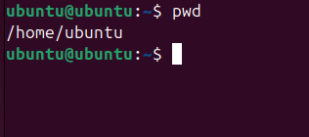
Ls: List of files
LL: list of files
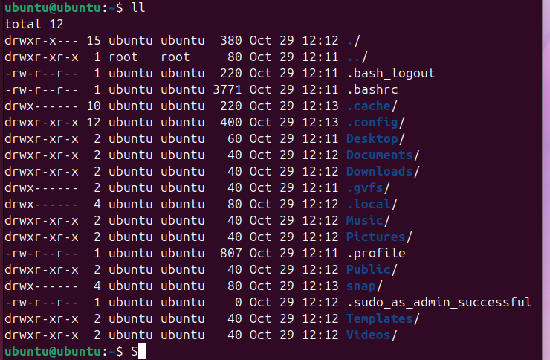
Cd: Change directory

Ls-a: List of hidden files
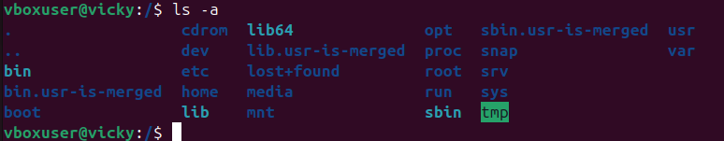
Clear: Clear the screen
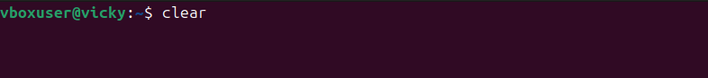
History: Show the history of commands
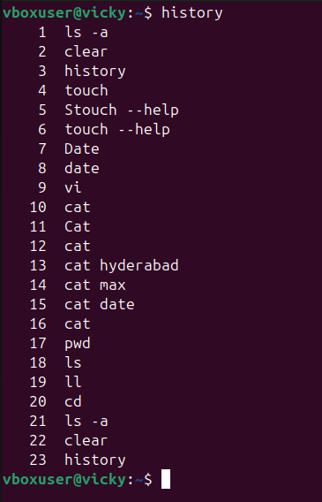

Touch: Create the file
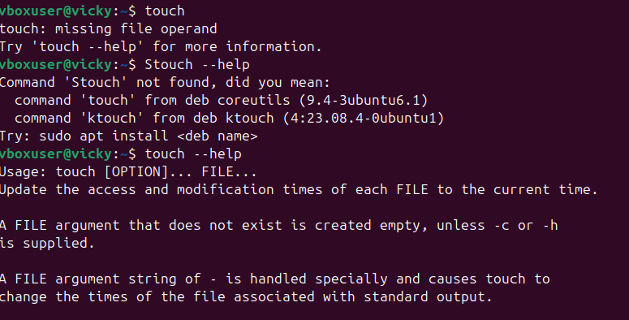
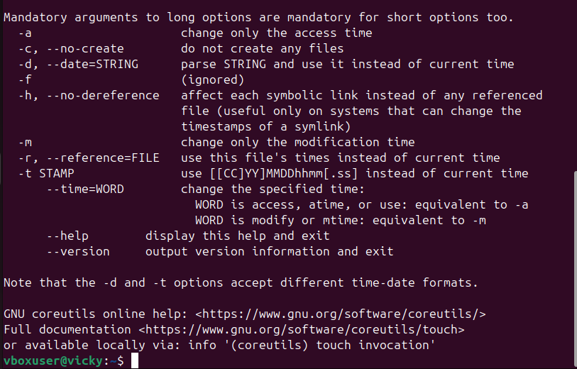
Date

Whoami: Shows the current user
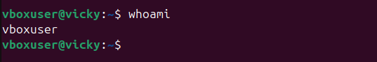
Mkdir: Created the directory
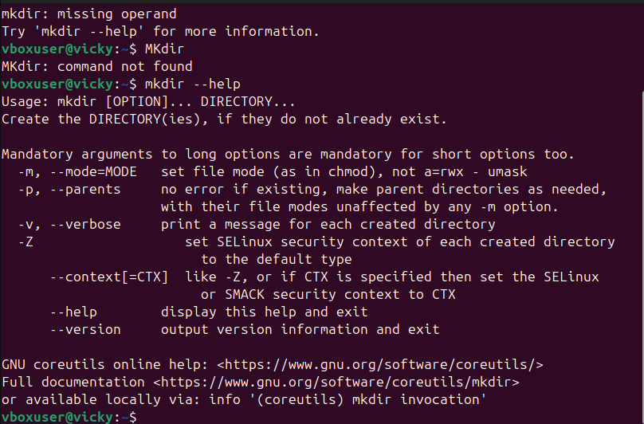
Rm-rf: remove the directory
Cd: go to home directory
Cd.. : This command helps us to go back one step back
from the current working directory
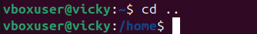

Ls -ltr: used in the terminal to list files in a directory in a detailed sorted way.
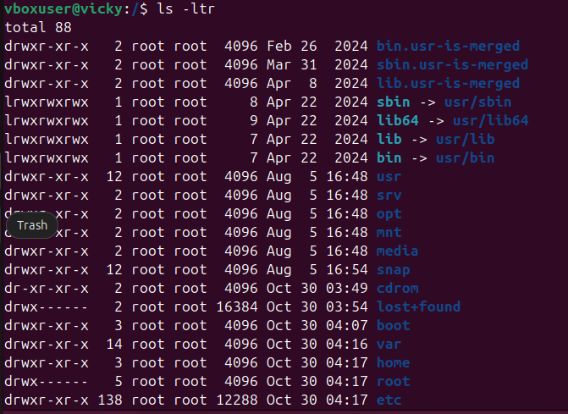
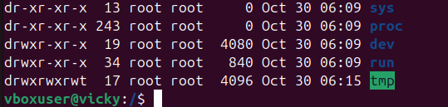

LL (long list): This command will show the complete information of the files in the working directory also it will show the complete files available in that directory.
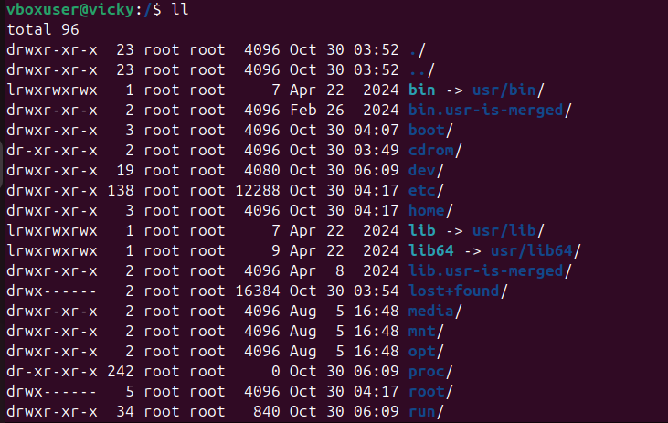
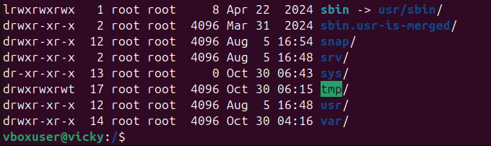
MV: This command will help us to rename the file name.
